Tasks on Terraform-05
1) Watch terraform-05 video.

Completed watching video.

2) Execute the script shown in video.
S3 Bucket is used as Remote Backend to store terraform.tfstate file. It will be the centralised file.
If we continuously edit template then we need to push and commit to the git repo each and every time. After backend setup if we make any modification and execute terraform apply then state file will be automatically pushed to central repo that is S3.
We can also use Terraform storage, Hashicorp console for this.

Create s3 using terraform:
=========================
resource "aws_s3_bucket" "s3_bucket" {
bucket = "s3backendterraform"
acl = "private"
}

terraform init – to install plugins of providers and other dependencies.
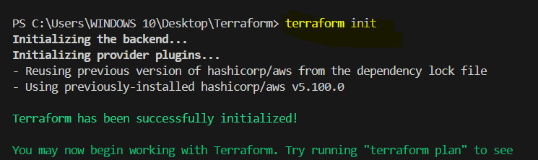

terraform apply – to execute the template.

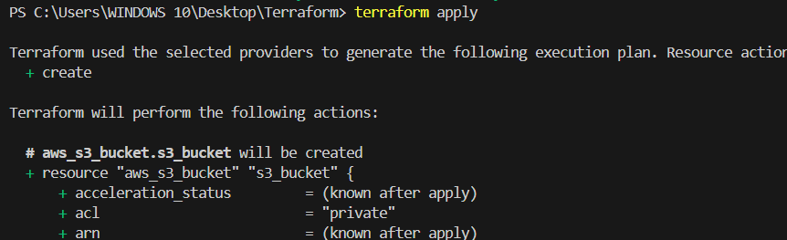
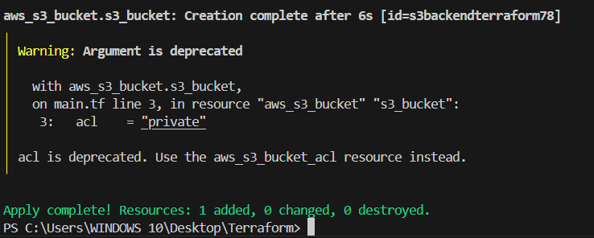

Verifying at AWS Console.
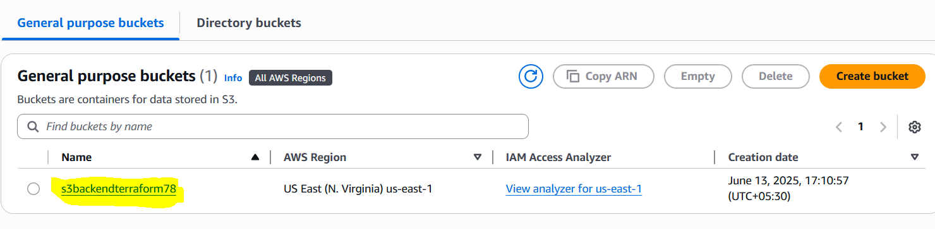

State locking is used to lock the state file so that no two users can execute the state file at the same point of time. We use dynamoDB for this.

Create dynamo db using terraform:
================================
resource "aws_dynamodb_table" "dynamodb-terraform-state-lock" {
name = "terraform-state-lock-dynamo"
hash_key = "LockID"
read_capacity = 20
write_capacity = 20

attribute {
name = "LockID"
type = "S"
}
}

terraform init – to install plugins of providers and other dependencies.
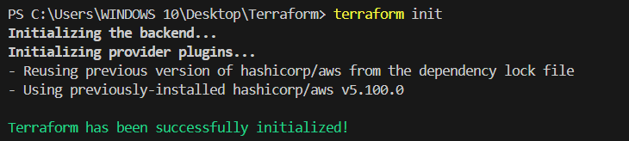

terraform apply – to execute the template.
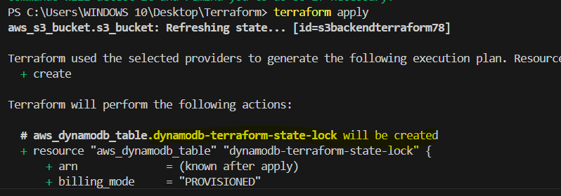
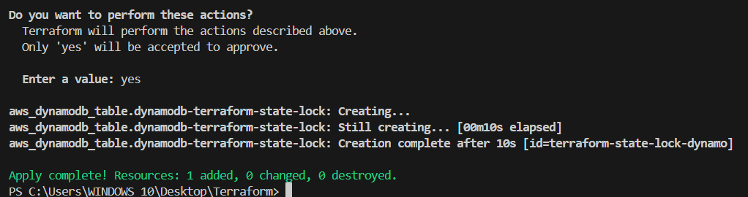

Verifying at AWS Console.
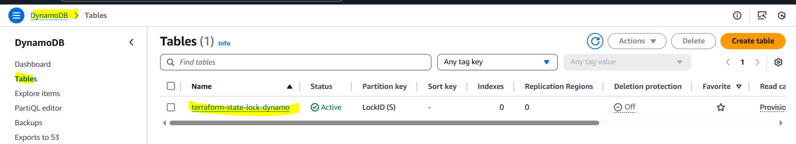

Terraform import:
================
Terraform import is used to import the existing infrastructure in terraform state file.
Once import is done then we cna be able to create/delete and manage the infrastructure.

In order to import any resource we need to write the resource details in configuration file.

This instance to be imported.

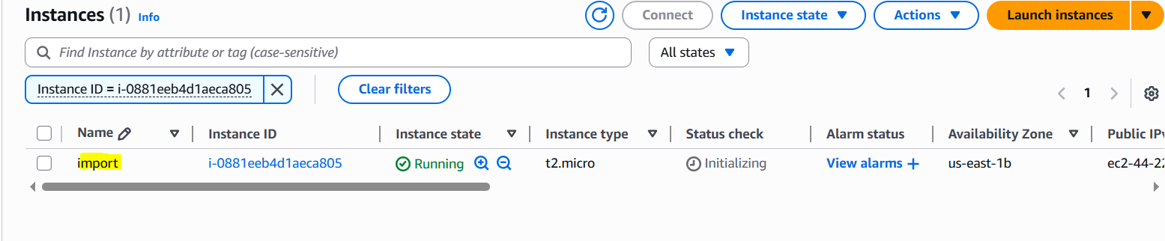
This template is required.

resource "aws_instance" "import" {
ami = ami-09e6f87a47903347c
instance_type = t2.micro
}

Need to run this command, terraform import aws_instance.<name> instance_id
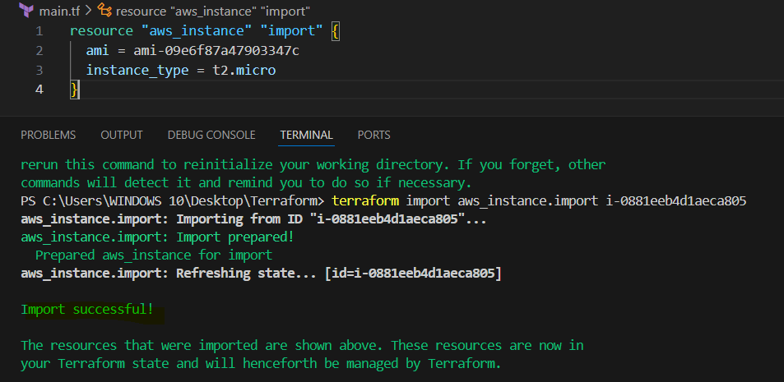

Now trying to delete the instance with terraform destroy.

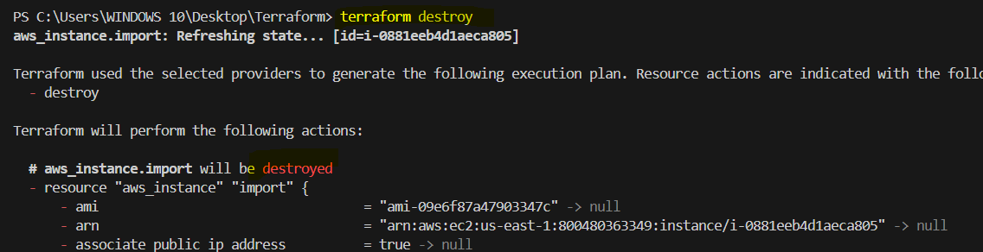

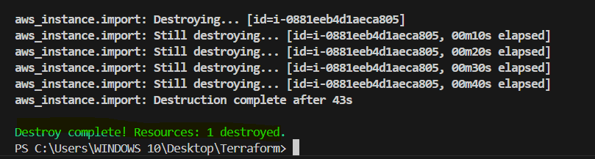

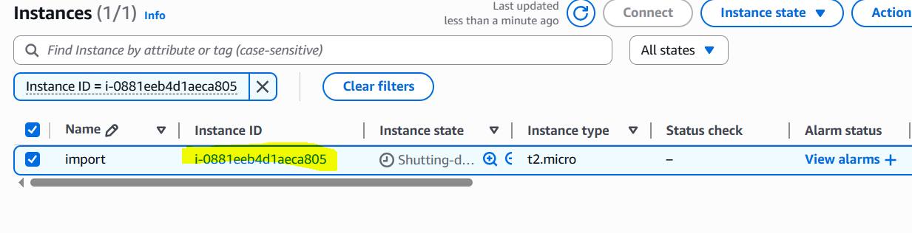

Debugging:
=========
terraform apply will provide us the logs/cause of the issue,
but still if we want to dig deeper then we need to export a varibale

export TF_LOG=TRACE - linux
Set-Item -Path env:TF_LOG -value "TRACE" - windows
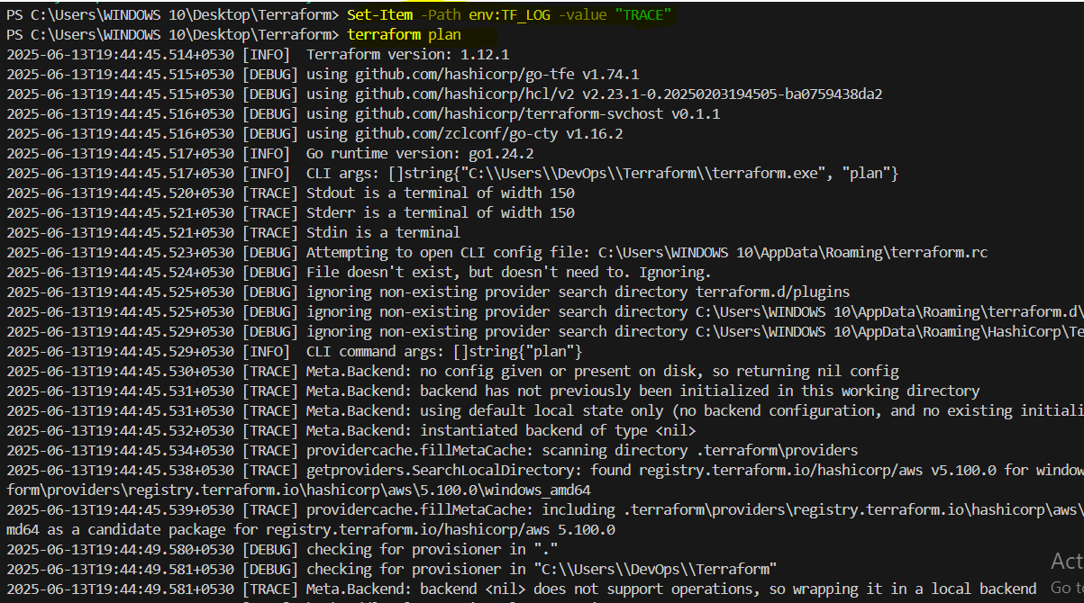

Terraform provides 5 levels of logs:
1) INFO
2) WARNING
3) ERROR
4) DEBUG
5) TRACE

To store the logs permanently then we can export a path, logs file will be created.

export TF_LOG_PATH=/tmp/terraform.log
Set-Item -Path env:TF_LOG_PATH -value "terraform.log"
Set-Item -Path env:TF_LOG -value "TRACE"
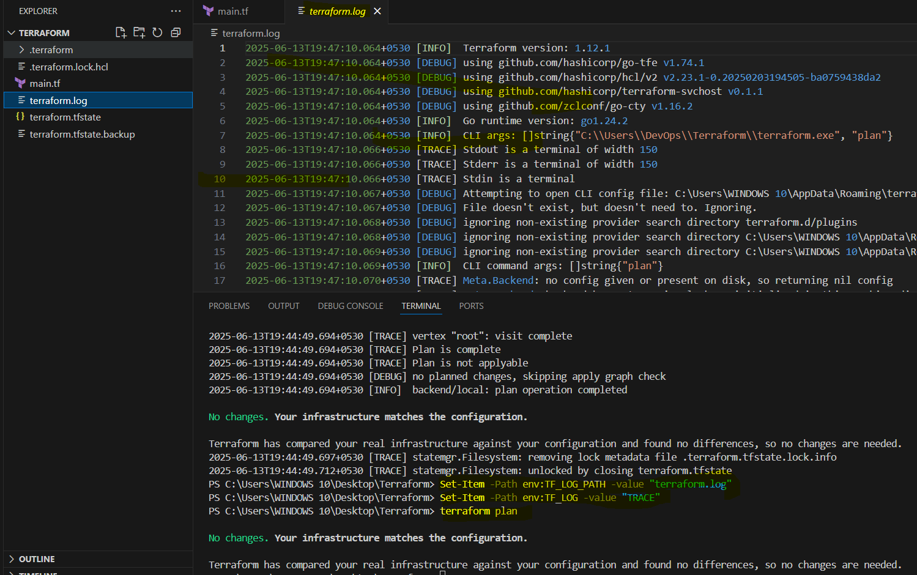

Terraform taint and untaint:
============================
Thee would be cases when resource creation will get failed,if this happens
then terraform will be marked as "Tainted".
we can see this when we execute terraform plan command and this will
be replaced when we use terraform apply command.

if for any reason you have installed manually in ec2 and you want that to be replaced in next apply
then we can manually mark that resource as taint in terraform so that it will be replaced next time when use apply.

terraform taint aws_instance.webserver
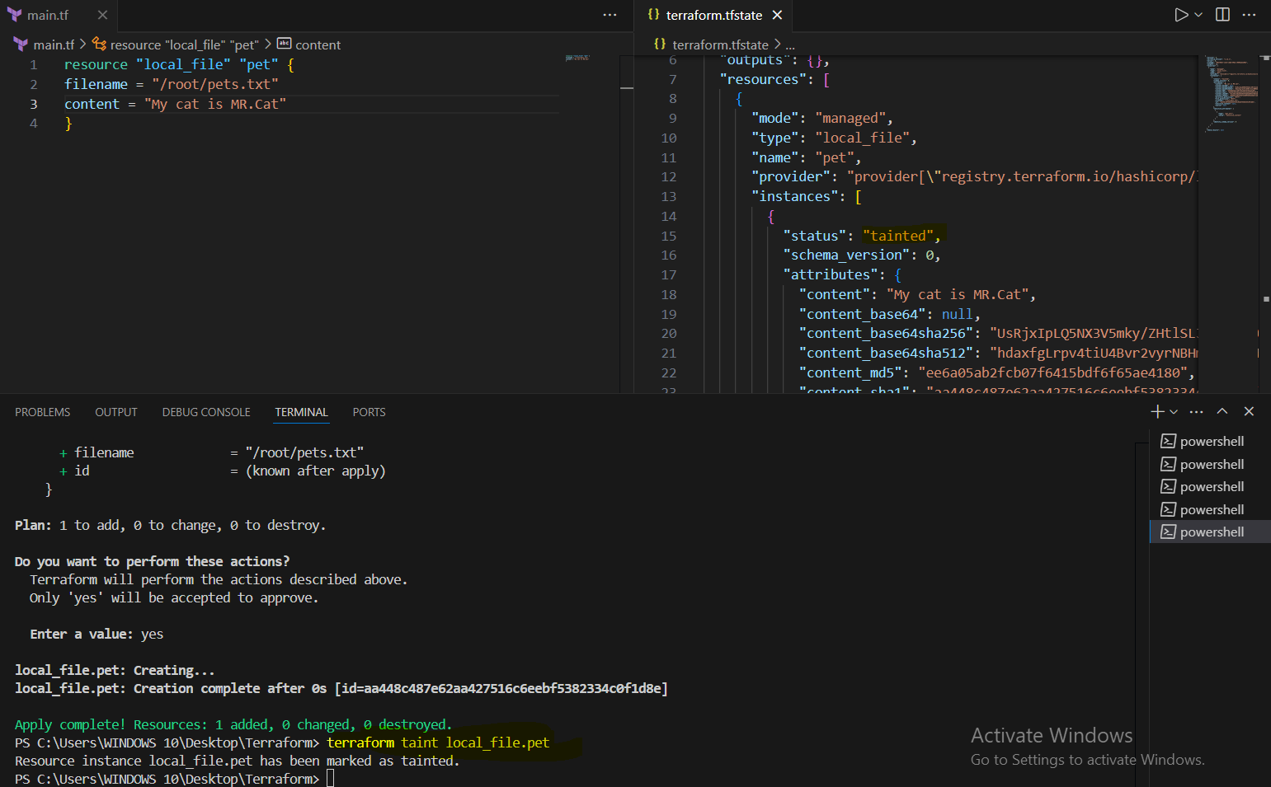

to undo the changes we can use untaint command.

terraform untaint aws_instance.webserver
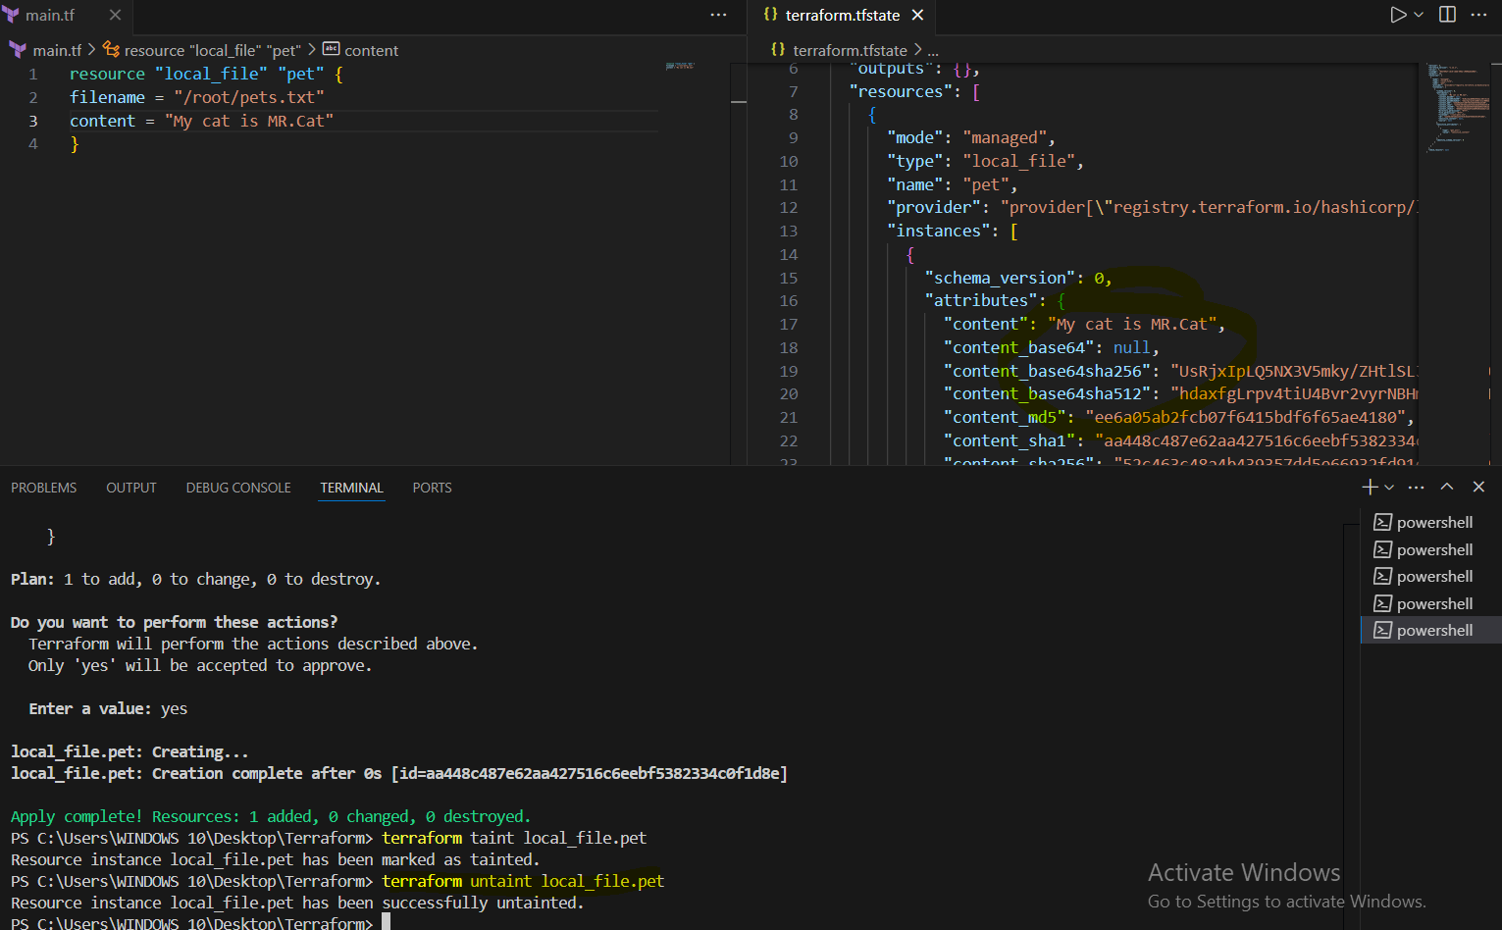
this resource will not be created when using terraform apply.
3) Create one ec2 instance with httpd installed using terraform script.

Used this Template to install ec2 with httpd.
resource "aws_instance" "httpd" {
ami = "ami-005f9685cb30f234b"
instance_type = "t2.micro"
key_name = "Virginia"
vpc_security_group_ids = ["sg-05a7015767640bf35"]

tags = {
Name = "httpd-server"
}

user_data = <<-EOF
#!/bin/bash
yum update -y
yum install -y httpd
echo "Welcome to httpd.tf" > /var/www/html/index.html
systemctl start httpd
systemctl enable httpd
EOF

provisioner "local-exec" {
command = "echo Instance ${aws_instance.httpd.public_ip} created! > instance_state.txt"
}
}

terraform init – to install plugins of providers and other dependencies.

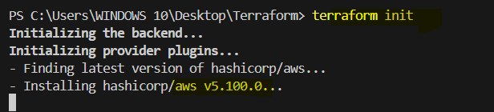

terraform apply – to execute the template.
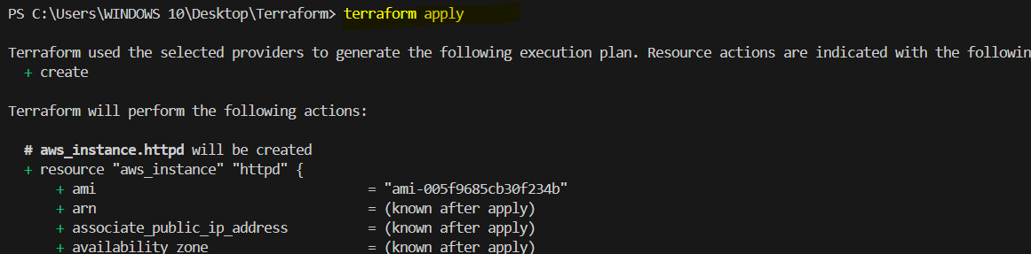
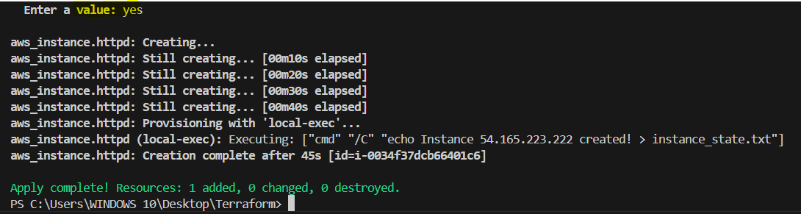

Let’s check output, Ec2 instance, httpd and provisioner file.
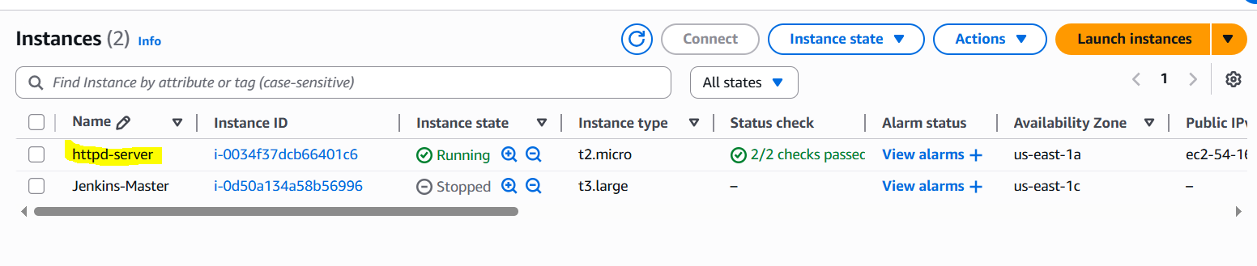
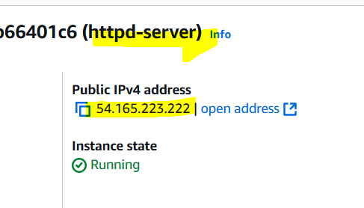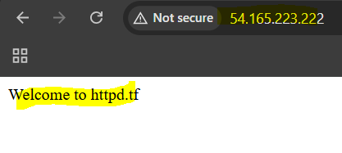

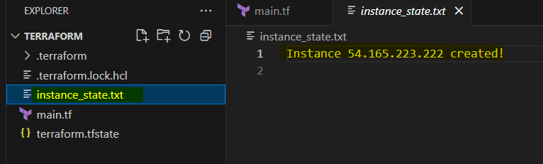

4) Setup s3 as backend to the task 3.

We already have a S3 Bucket with the name as s3backendterraform78 so we can setup this bucket as backend for the task 3.

terraform {
backend "s3" {
bucket = "s3backendterraform78"
key = "terraform.tfstate"
region = "us-east-1"
}
}

Need to add this template then terraform init.

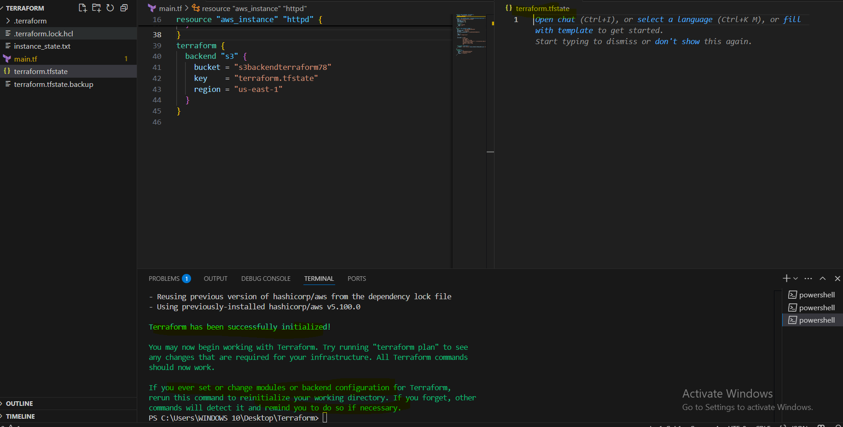

We can see that state file is empty now.
Verifying S3 Bucket with task 3.

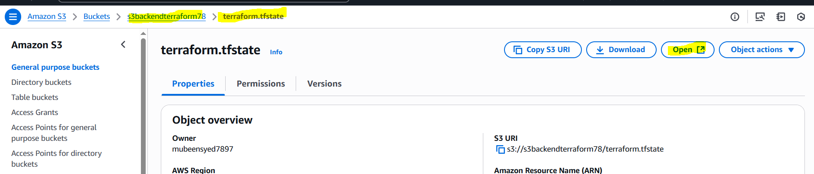

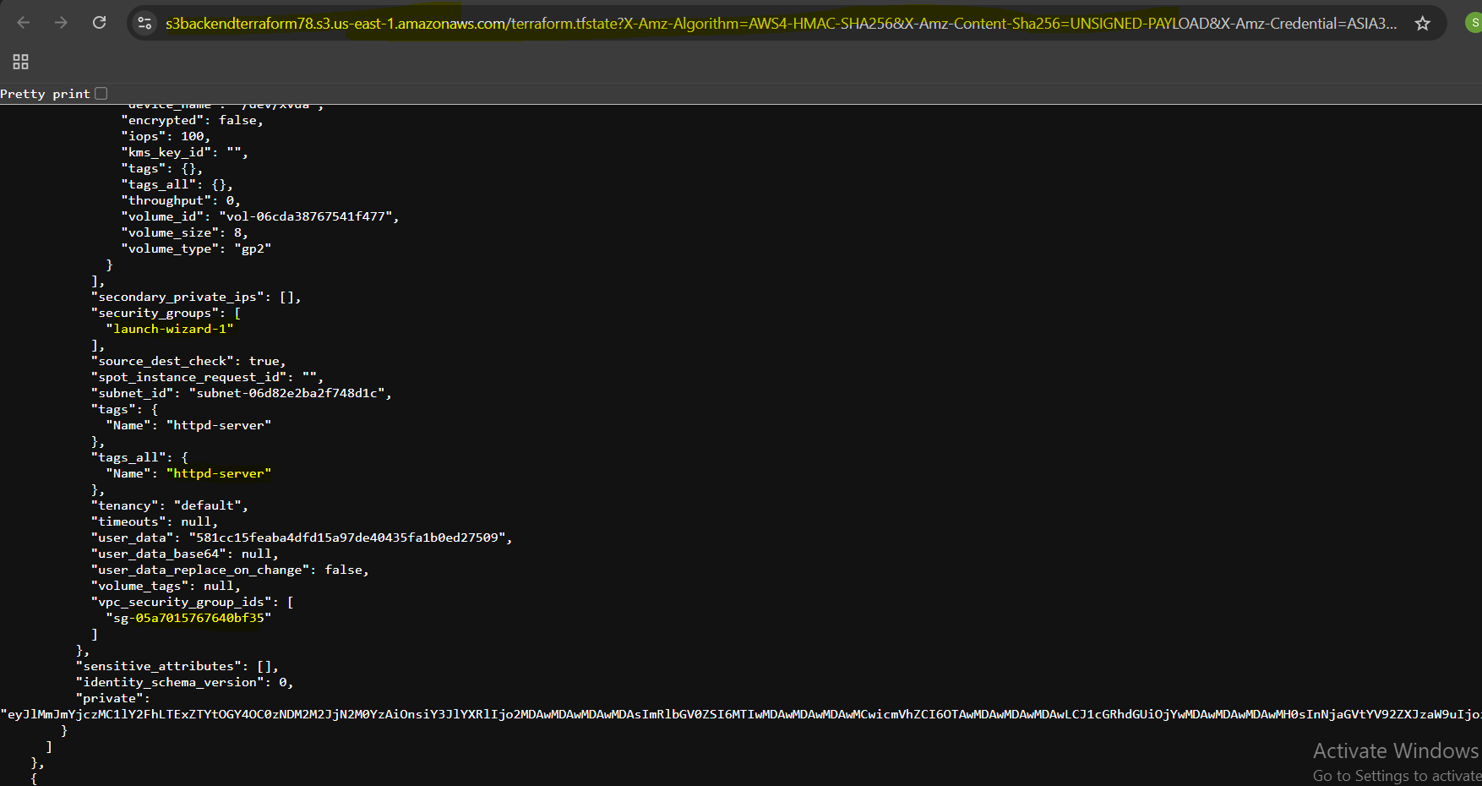

5) Setup dynamo db locking for task3.

We have already created DynamoDB with name terraform-state-lock-dynamo so we can setup this for db locking for task 3.

terraform {
backend "s3" {
bucket = "s3backendterraform78"
key = "terraform.tfstate"
region = "us-east-1"
dynamodb_table = "terraform-state-lock-dynamo"
}
}

Need to add this template then terraform init -reconfigure. As I already configured s3 bucket to backend that’s the reason used -reconfigure. Otherwise we can configure both at same tiem using the below template.

terraform {
backend "s3" {
bucket = "s3backend"
dynamodb_table = "terraform-state-lock-dynamo"
key = "terraform.tfstate"
region = "us-east-1"
}
}

terraform init -reconfigure

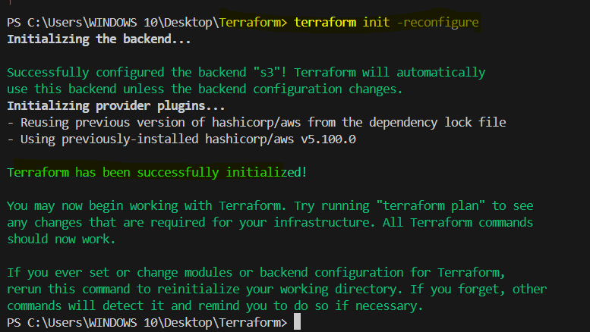

To verify need to run commands from two different terminals.
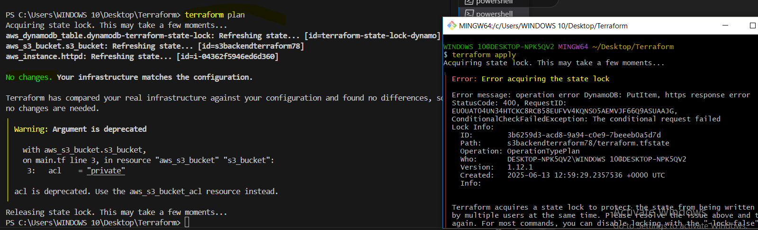

Verifying at console.
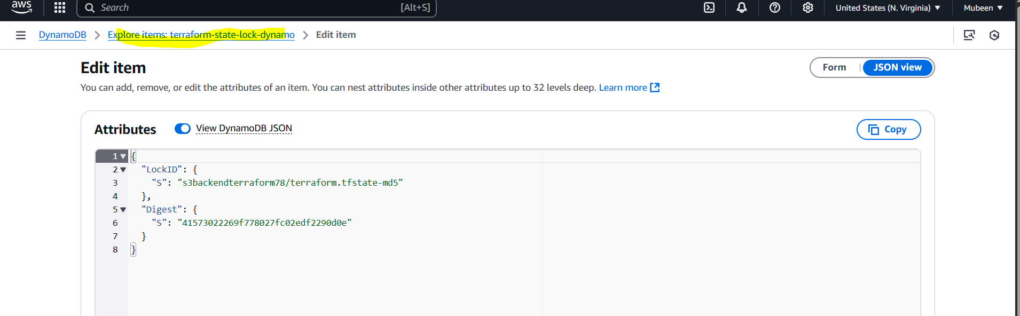

THE-END

